Name: Aysar weshahi

Yazan Jarrar

Yazan khalaf

……………………………………………………….

Introduction:

in this time , I become the library is bigger and bigger than befor,And the process to controlling to noise is de So must be solve the problem .

Solution is product use to keep the library quiet , using sensors and mobile application (use Bluetooth).

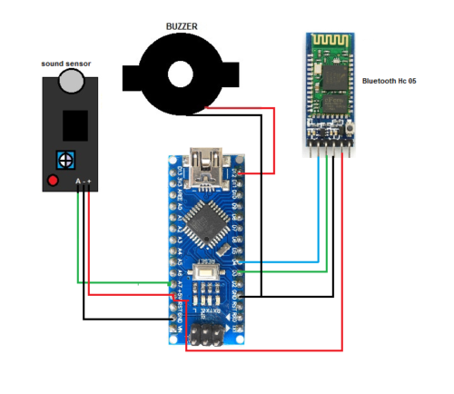

|  |  |
| --- | --- |
| advantage | disadvantage |
| sample | Annoying |
| save sound | small range use (because use Bluetooth) |
| faster | use one mobile |
| small |  |

On the other hand this system not perfect the system to group work is best than it because:

|  |  |
| --- | --- |
| Proj1 | Group proj |
| Can’t use many mobile in this project | Can it |
| Use Bluetooth | Use network (local) |
| Noise | No noise |

............................................................

introduction:

In This project not limited to the library but to other things such as bedrooms, classrooms, etc. And the project built in Object-Oriented programming and Arduino. As it helps explore many aspects of Digital

Technologies, including digital systems, data representation, algorithm design and the project read a sound every 10ms.

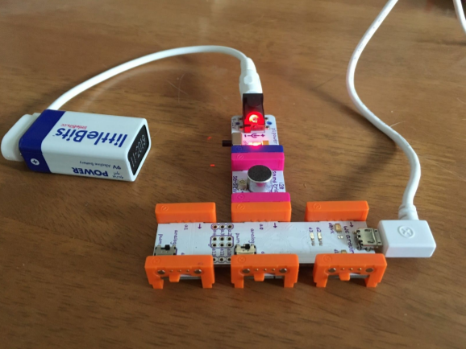

|  |  |
| --- | --- |
| advantage | disadvantage |
| Many use (any where) | Need power(9v) |
| Network connection | Using computer(can’t use mobile) |
| Response speed and noise distinction | One user only |
| Save sound | Using cable network to connection project and computer |

If we can best than proj1 but not best than group project

This is because :-

|  |  |
| --- | --- |
| Proj2 | Group project |
| One user(owner) | Can multiple users (owner) |
| Connection with cable | Connection in WIFI |
| Using computer (one only) | Using mobile (can more than one( |
| Using complex digital and Arduino and Object-Oriented programming | Using Arduino |

...........................................................

1- https://www.electronicsforu.com/electronics-projects/noise-detector-automatic-recording-system

2-https://csermoocs.adelaide.edu.au/library/ProjectCaseStudy-NoiseAlarm.pdf